Project Design Phase
Solution Architecture

Date | 26 September 2026
Team ID | SWTID-2026-9430
Project Name | AI BlogNest API
Maximum Marks | 4 Marks

Solution Architecture – AI BlogNest
Solution Architecture is the process of designing the technical structure of AI BlogNest to connect users’ blogging needs with an effective AI-powered solution. Its main objectives are to:

- Identify suitable technologies and AI services to solve common blog creation and content management problems.

- Define the architecture, components, functionality, and interactions of AI BlogNest for project stakeholders and developers.

- Specify the major features, development stages, system requirements, and AI capabilities needed to build the platform.

- Provide a clear technical framework for developing, managing, integrating, and delivering the AI BlogNest solution.

Example: Solution Architecture Diagram

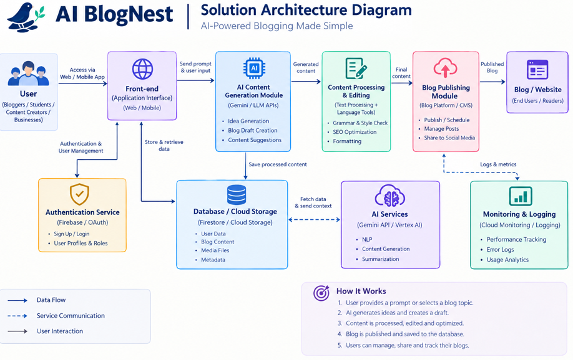

Reference:
https://aws.amazon.com/blogs/industries/voice-applications-in-clinical-research-powered-by-ai-on-aws-part-1-architecture-and-design-considerations/

